**2018 Global Goals Challenge**

The UNAAWA Global Goals Challenge recognises outstanding school-student-led projects or innovations implementing the UN Sustainable Development Goals. The judges looked for the project scope and innovation, students' leadership skills and project impact.

**FINALISTS**

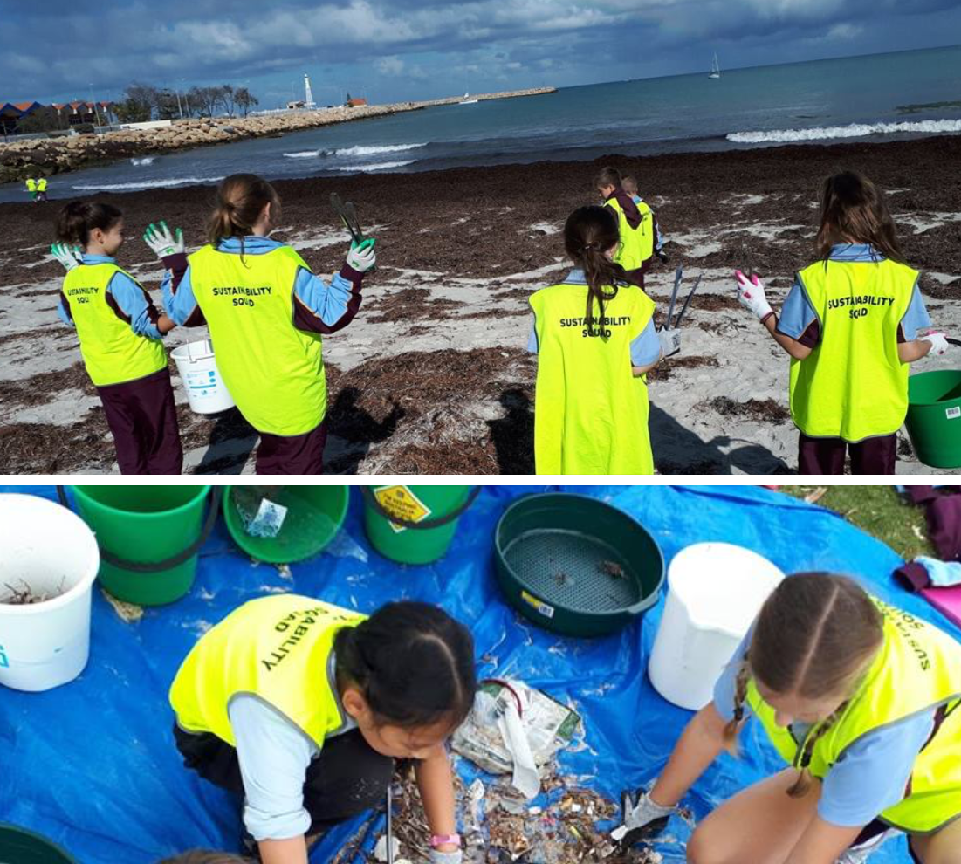

**Changing the Way We Think: Impact of One Use Plastic**

**St Mark's Anglican Community School**

Four Year 5 students led the project involving four Year 4 classes. They worked with NarcDive, Keep Australia Beautiful and Tangaroa Blue Foundation in a service project auditing rubbish collected at the local beach. Findings were reported culminating in an Inquiry Project aiming to make the local community more aware of the impact they are having on the local environment. Students applied their persuasive writing skills and wrote a Global Goals Rap to build awareness and change thinking.

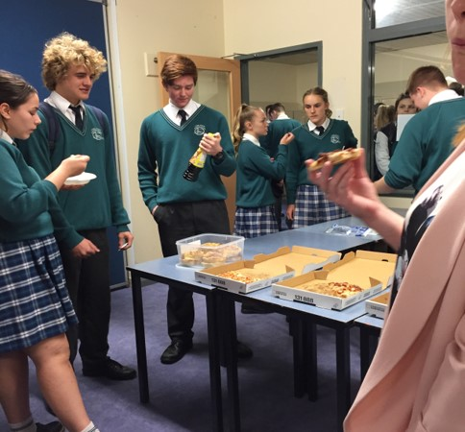

**Global Lunch, Living Waters Lutheran College**

Year 11 General Business Management and Enterprise students used the curriculum to design, develop, market and deliver a “product or service” to the College Community – the Global Lunch (related to SDGs 1, 2, 3, 4, 6 and 10). The lunch received was based on an element of chance, through a raffle, to demonstrate the unfairness in the inequality of global wealth. Pre and post surveys measured impact of the project on raising awareness of global issues.

The cost of the lunch was $2, to reflect the large number of people living on less than $2 day.

Three lunch options were allocated: 70% received Rice and broth; 30% could choose between Pizza, quiche or Sushi

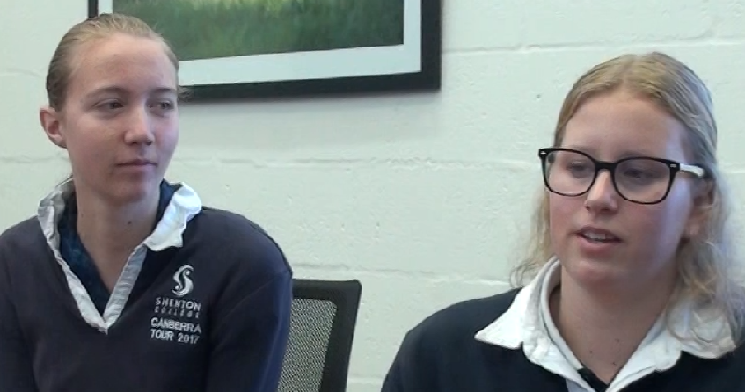

***Edutunities*: Olivia Dodd and Sophie Styles, Shenton College**

Olivia and Sophie are passionate about providing equal access to education opportunities (SDG 4 Target 4.5). In their Year 10 STEM class they designed a website and portal to facilitate interaction and peer mentoring between remote rural and well-resourced metropolitan schools in WA. Their design was influenced by feedback gathered from Hedland SHS. The promotional video and blog designed by the students provide information on their innovation. See: <https://livandsoph.wixsite.com/10stem2018>

Olivia and Sophie plan to present their prototype to Education Department executives.



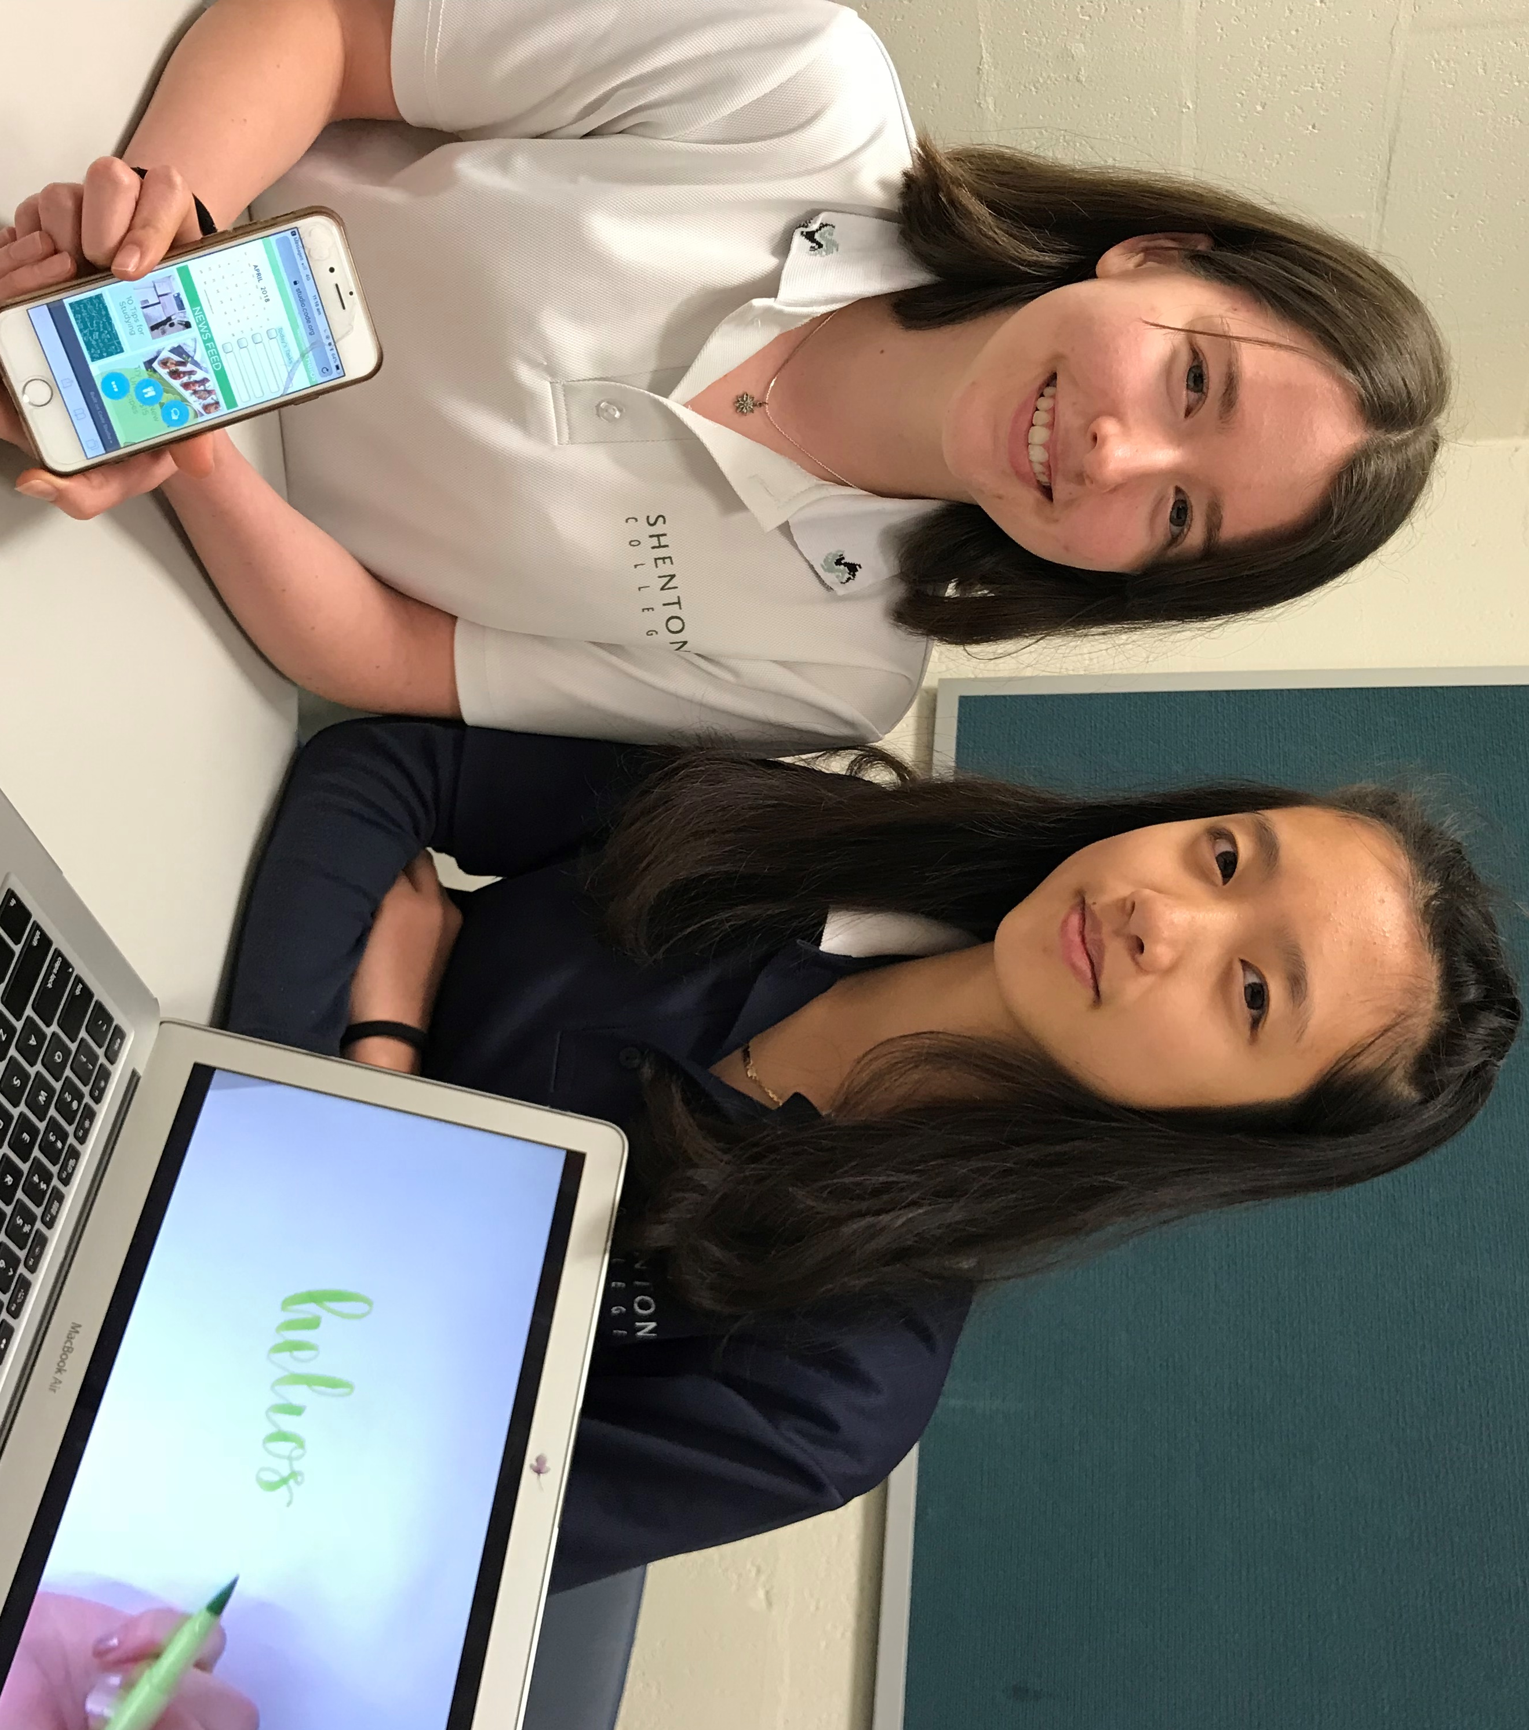

***Helios*: Genevieve Le and Elizabeth Tweedie, Shenton College**

Lizzie and Genevieve want to make a change by helping their peers manage stress and promote mental health and wellbeing (SDG 3, Target 3.4). Their research identified poor organisational skills and ineffective use of paper diaries as key stress factors. They developed an App prototype, gathered peer feedback to refine, tested it with Year 9 students and provided an information session for parents. The promotional video and website provide further information. See: <https://10stem2018genzie.weebly.com/> A proposal to replace the school diary with the App has been presented to school leaders.

**JUDGING PANEL**

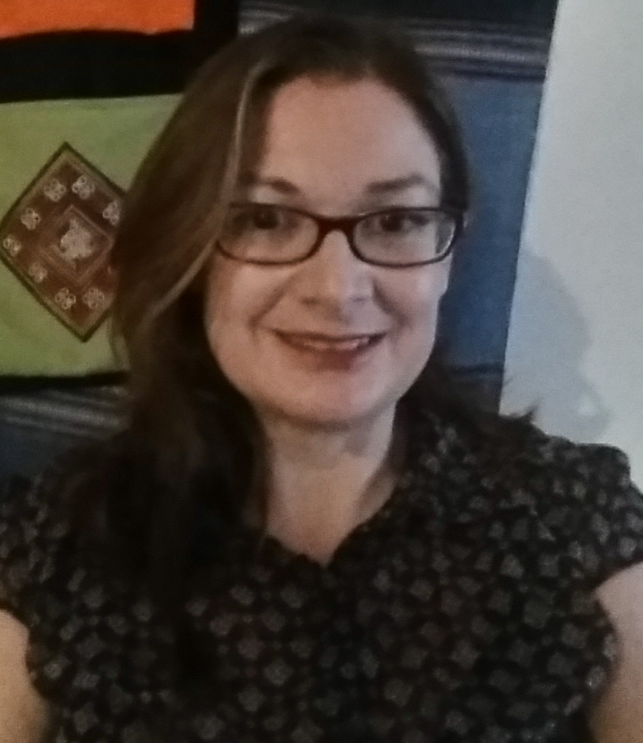

Dr Caroline Marsh (One World Centre)

Caroline is Education Coordinator at the One World Centre, representing it on several groups working towards a just and sustainable future for all, including the Sustainable Schools Alliance and WA SDG network. "I'm passionate about empowering learners to build global competencies through transformative education. I believe in local action for global change: every day we can make choices and take actions that have global impact and create a better future for all."

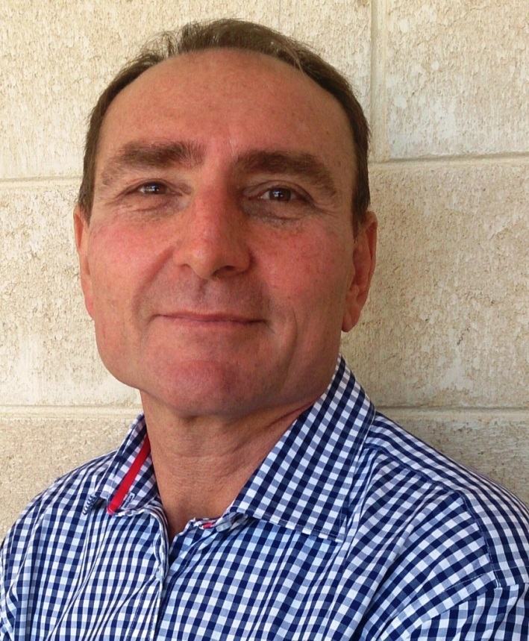

**Paul Moro (Foundation for Educational Digital Development)**

Paul has over 27 years’ experience in the education and training industries, with specialised expertise in professional learning, curriculum development and building computing technology solutions for schools.  He has extensive experience working with schools in the delivery of pedagogically grounded technology learning.  "The Global Goals Challenge is a great vehicle for students to apply the technology, design and entrepreneurship skills essential for sustainable futures in the digital economy."

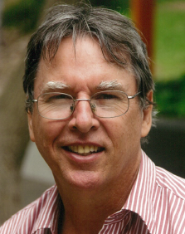

**Dr Peter Devereux (Curtin University Sustainability Policy Unit)**

Peter lectures in the Sustainable Development Goals Masters Unit at Curtin University. For the past 30 years he has focused on volunteering and sustainability policy and is currently developing a guide on their links with the Sustainable Development Goals. Previously he worked as UN staff in Germany, volunteered on SDGs research in Myanmar; and as environmental adviser in Nicaragua. "The Global Goals Challenge encourages students to design practical solutions for sustainability while exploring their passions and engaging their fellow students.”



**Pia Munindradrasa (Project Coordinator Curtin AHEAD)**

Pia has extensive experience in the areas of equity and social justice reaching to WA’s most educationally disengaged and disadvantaged.As the Project Lead for AHEAD in Communities, Pia aims to increase access to education for incarcerated students and address educational barriers within the justice system. "Student engagement with the SDGs provides an opportunity to develop innovative solutions that challenge economic, social, and educational barriers - crucial if we are to *Leave No One Behind*."

Chris West (WA Super)

Chris is the General Manager Investments at WA Super. He is responsible for implementing the Sustainable Future Investment option "that invests in companies addressing the UN Sustainable Development Goals. Our Sustainable Future investment option sits in the realm of Impact Investing and is one of the first of its kind in Australia. It's designed to improve the lives of people around the world and deliver attractive long-term returns. Investments are directed to innovative companies addressing the world’s major social and environmental challenges."

